Name:-Suhas Madhukar Kolse

Roll No.:-E43039

VHDL Code:-library IEEE;

use IEEE.STD_LOGIC_1164.ALL;

entity HA_3039 is

Port ( A : in STD_LOGIC;

B : in STD_LOGIC;

S : out STD_LOGIC;

C : out STD_LOGIC);

end HA_3039;

architecture Behavioral of HA_3039 is

begin

S<= A XOR B;

C<=A AND B;

end Behavioral;

RTL Schematic:-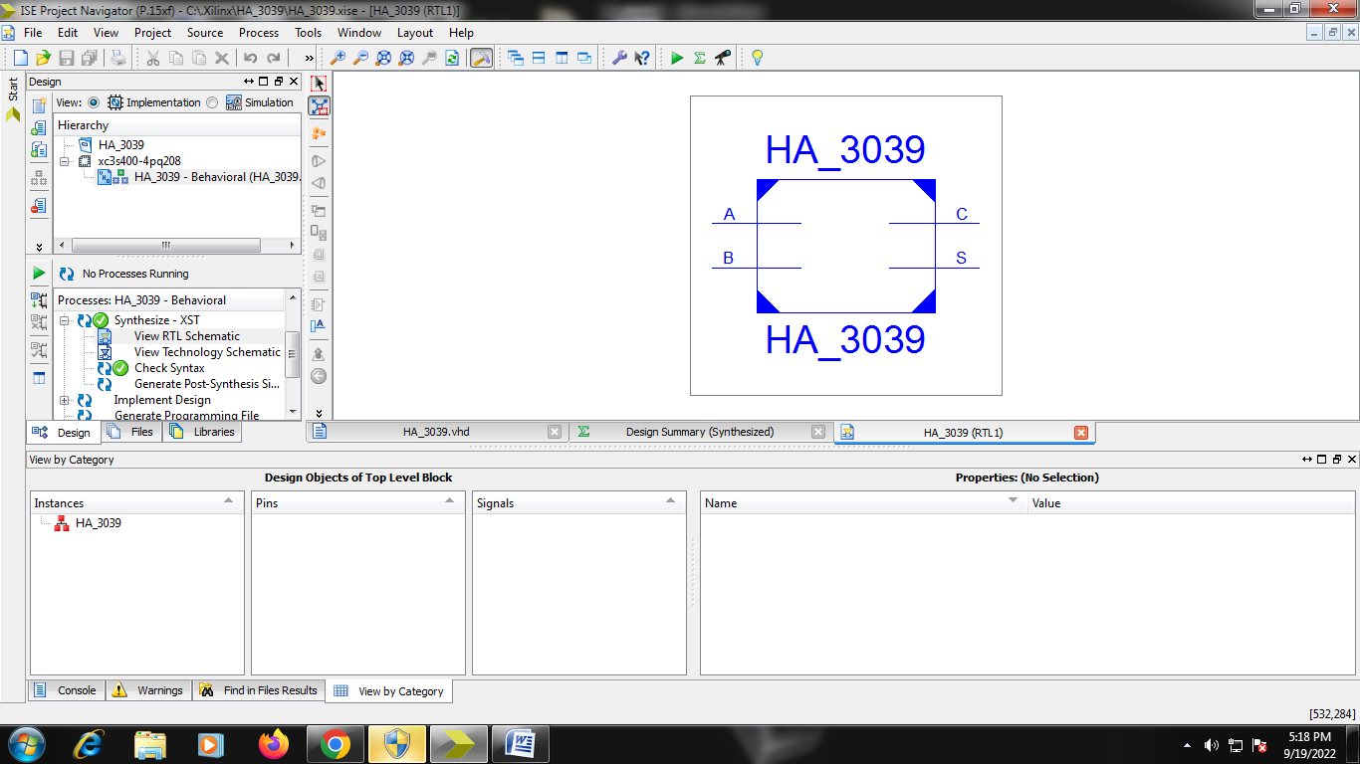

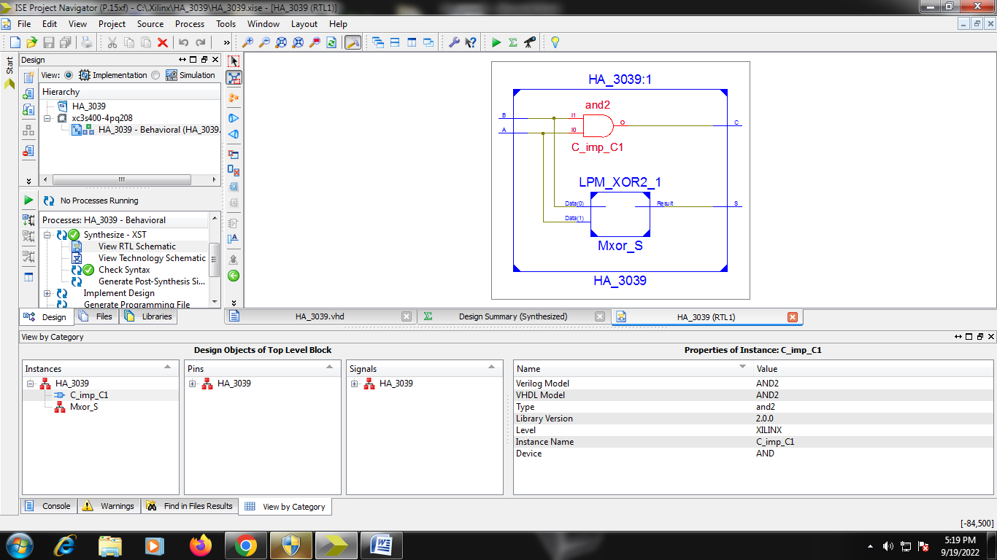

Design Summary:- 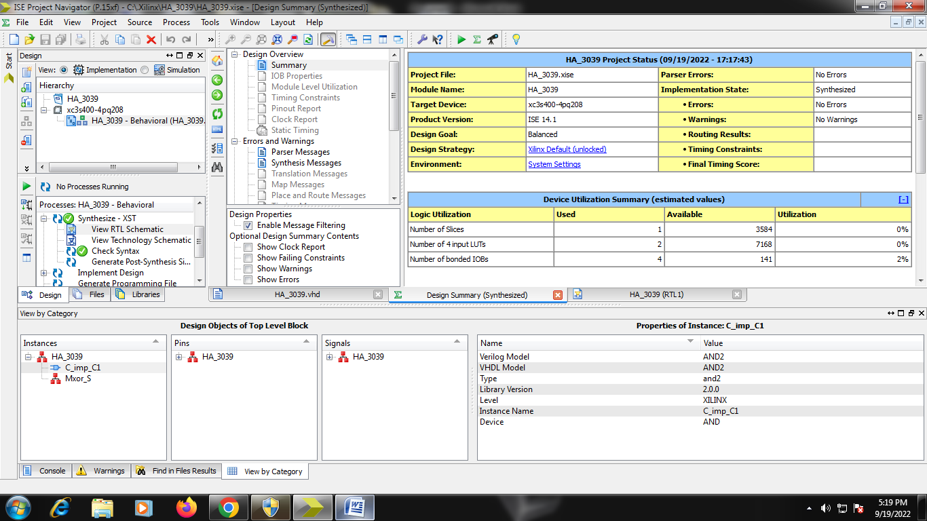

Test_bench:- LIBRARY ieee;

USE ieee.std_logic_1164.ALL;

ENTITY HA_TB_3039 IS

END HA_TB_3039;

ARCHITECTURE behavior OF HA_TB_3039 IS

COMPONENT HA_3039

PORT(

A : IN std_logic;

B : IN std_logic;

S : OUT std_logic;

C : OUT std_logic

);

END COMPONENT;

--Inputs

signal A : std_logic := '0';

signal B : std_logic := '0';

--Outputs

signal S : std_logic;

signal C : std_logic;

BEGIN

-- Instantiate the Unit Under Test (UUT)

uut: HA_3039 PORT MAP (

A => A,

B => B,

S => S,

C => C

);

-- Stimulus process

stim_proc: process

begin

A<='0';

B<='0';

Wait for 100 ns;

A<='0';

B<='1';

Wait for 100 ns;

A<='1';

B<='0';

Wait for 100 ns;

A<='1';

B<='1';

Wait for 100 ns ;

-- hold reset state for 100 ns.

wait for 100 ns;

-- insert stimulus here

wait;

end process;

END;

Waveform:=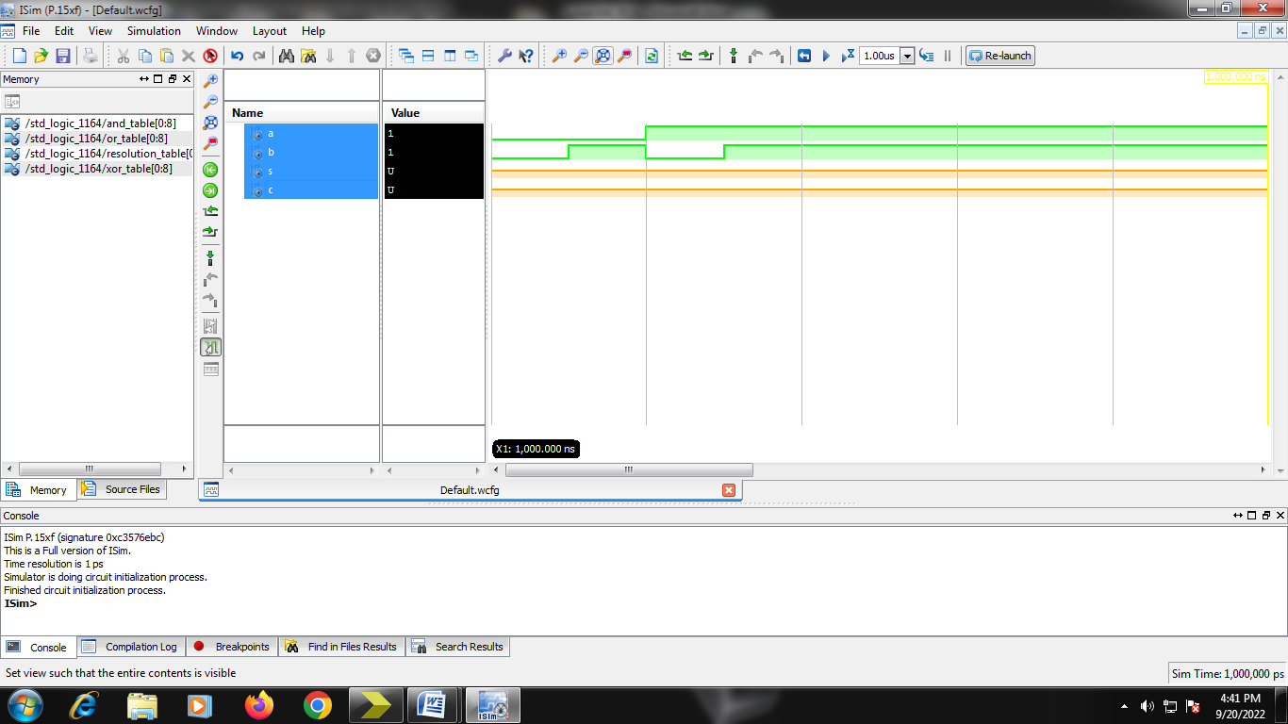

=========================================================================

* Final Report *

=========================================================================

Clock Information:

No clock signals found in this design

Asynchronous Control Signals Information:

No asynchronous control signals found in this design

Timing Summary:

Speed Grade: -4

Minimum period: No path found

Minimum input arrival time before clock: No path found

Maximum output required time after clock: No path found

Maximum combinational path delay: 9.033ns

=========================================================================

Process "Synthesize - XST" completed successfully